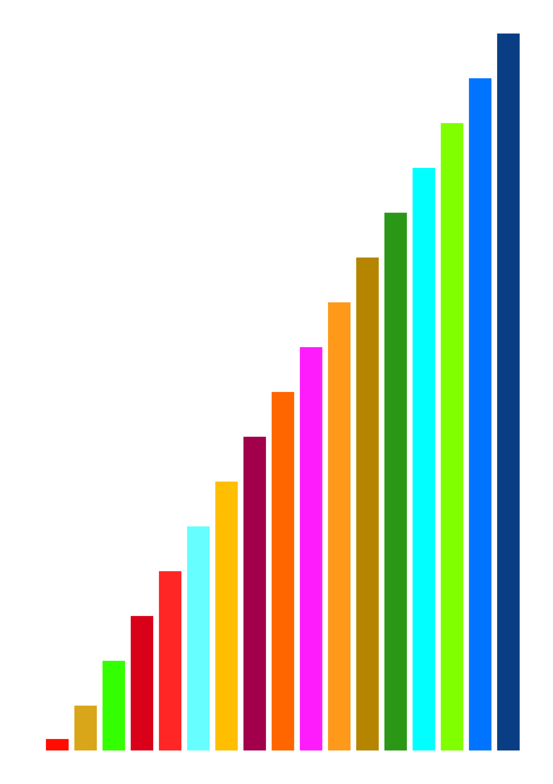

THE 4-4-2

4 NEWS – 4 GLANCES – 2 QUESTIONS

ECONOMIC BULLETIN

Strong US Dollar, High Interest Rates, global growth slowdown: The implications for Mauritius

October 2022

|  |  |  |
| --- | --- | --- |
| **Persisting inflation and strong US Dollar** | | |
| Upward trend with solid fill  By the end of 2021, after COVID restrictions were progressively lifted, a strong rebound in demand, high commodity prices and persisting supply chain disruptions fueled global inflation, which accelerated when oil and food prices skyrocketed after the invasion of Ukraine | | Dollar with solid fill  The value of the US Dollar, a traditional haven in times of crises and uncertainty, is very high, with critical implication for emerging economies, especially when Foreign Direct Investment is a driver of growth, and for heavily indebted countries |
| **Hiking interest rates and possible global recession** | | |
| Muscular arm  To fight inflation by cooling global demand and investments, Central Banks around the World, and among them the US Federal Bank, are increasing their interest rates aggressively, raising fears of a global recession | Gauge  GDP growth should slow in 2022 and probably throughout 2023, because of inflation and the combined effect of monetary policies around the World, as well as bad performance from major markets (China, Europe, US) for different reasons | |

*4 news of…*

Glance #1: Commodity prices’ ups and downs, and steady core inflation

*4 GLANCES AT…*

1. The rebound in economic activity following COVID-19, in a context of disrupted supply chains, drove global prices up progressively in 2021. The Ukraine war turbocharged inflation from March 2022 by exerting upward pressure on commodity prices. Core inflation (when all or almost all prices rise) is now installed, going way beyond commodity prices.
2. Oil prices are down 25% since June but the OPEC+ (the cartel of Oil Producing Countries + Russia) announced on the 5th of October their intention to cut production (by 2% of global supply) to **send oil prices up again**. Although the outcome of this decision is far from certain, low storage levels of both oil and gas may **keep energy prices high at least throughout 2023**.
3. Continued inflation, even if core inflation is cooling and only energy prices remain high in the coming months, will **weigh heavily on public and private finances**, hitting the **most vulnerable households the hardest**, and calling for Government support for the poorest.

*Source: INSEE,* [*International Prices of Raw Materials*](https://www.insee.fr/en/statistiques/serie/010753754)*, October 2022 and World Bank,* [*Commodity markets (pink sheet)*](https://www.worldbank.org/en/research/commodity-markets)*, October 2022*

Glance #2: A strong US dollar affects public finances, investment, and imports

*4 GLANCES AT…*

1. In times of crises, the Dollar is always seen by investors as a haven, and with US Federal Reserve’s interest rates rising, the return on investment is bigger. These concomitant factors strengthened the US Dollar, which reached its highest level ever in front of several currencies.
2. **Strategic imports, especially fuel**, are mostly paid in dollars and will be more expensive due to higher exchange rates. Financial services, and especially the attractiveness of Mauritian financing instruments, will also be affected.
3. This also makes **servicing debt contracted in US dollars more expensive**, weighing heavier on public finances. In Mauritius, a limited share of Government debt is serviced in US Dollar, yet 100% of public enterprises guaranteed debt is in this currency, for a total significant amount of 31 billion rupees, making it the main currency for servicing debt, together with Euro. **Mauritius public debt as a % of GDP was 86.4% in June 2022**.
4. Though usually an upside of a weak rupee, **competitivity gains may be limited**, in a context of global demand slowdown and general currencies’ weakness against the dollar.

*Source: Bank of Mauritius,* [*Consolidated indicative exchange rates*](https://www.bom.mu/markets/foreign-exchange/consolidated-indicative-exchange-rates?field_transaction_date_value%5Bvalue%5D%5Bdate%5D=01-10-2021&field_transaction_date_value_1%5Bvalue%5D%5Bdate%5D=03-10-2022&field_country_tid=39&page=25)*, and author’s calculations based on* [*Currency composition of Government external debt*](https://mof.govmu.org/Pages/Debt-Data.aspx)*, 2022*

Glance #3: Global economic slowdown’s implications for Mauritius

*4 GLANCES AT…*

1. Overwhelming inflation was already putting downward pressure on demand. The impact of Ukraine war in Europe, of the zero-COVID policy and real estate crisis in China and of hiking interest rates in the US and elsewhere are driving a global economic slowdown that could turn into global recession in at least part of 2023.
2. This global recession would in turn affect Mauritius economy by potentially slowing tourists’ arrivals and spendings, manufacturing exports, demand for ITC and financial services… affecting every driver of economic recovery
3. **Public finance** will suffer too, with a decrease in revenues from tourism and economic activity in general, and the **commercial deficit would increase**, as imports are less likely to decrease than exports, in a context of high dependence on strategic imports (food, fuel, etc.) and high concentration of exports (tourism, manufacturing, etc.).

*Source: The Economist Intelligence Unit,* [*Global and regional growth projections*](https://viewpoint.eiu.com/analysis/article/1772424160?utm_source=mkt-newsletter&utm_medium=email&utm_campaign=Intelligence-today-03/10/2022&utm_term=longer-term&utm_content=anchor-1&mkt_tok=NzUzLVJJUS00MzgAAAGHOvnC256_0KI0nEM0qQhS8Irb8-v6QAjD559ttZ8svRHQFL_Jx-6_jJ7CS2Ntllw5CWIgY6OZWZXsSHpcxDfzfYuwvpafTIeItAO0Vn7ycRt6dw)*, October 2022 and IMF,* [*World Economic Outlook Database*](https://www.imf.org/en/Publications/WEO/weo-database/2022/October/download-entire-database)*, October 2022*

Glance#4: Mauritius next economic frontiers

1. The projections for key economic indicators for Mauritius, in this challenging global context, are rather gloomy, with a **limited growth, declining investments, and stagnating unemployment rate** during the next 5 years

*4 GLANCES AT…*

1. Although climate change will continue to impact the country on the long run, the other crises are but the symptoms of a profound shift between the era of unfettered globalization of the last 50 years, and a new era more focused on resilience, with **regionalization and localization as important megatrends**. This will open new opportunities for renewed economic development if the country is well prepared.
2. Beyond the contribution of fisheries to food systems and of renewable energies to energetic transition, both in a vision of **self-reliance and resilience**, the blue economy presents great potential in Mauritius in the sectors of renewable energies, high-end ocean-based food production, maritime transport, ICT services and blue biotech.
3. Harnessing **ocean-based renewable energies**, reinforcing **small-scale fisheries**, offering **sustainable shipping** (and related) services, exploring possibilities linked to blue **biotechnologies**, should untap the potential of the blue economy in Mauritius, leading to the creation of around 9,000 jobs.

*Source: IMF,* [*World Economic Outlook Database*](https://www.imf.org/en/Publications/WEO/weo-database/2022/October/download-entire-database)*, October 2022 and World Bank,* [*The*](https://ine.cv/quadros/estatistica-do-mercado-trabalho-inquerito-multi-objetivo-continuo-2020/) *Ocean Economy in Mauritius. Making it happen, making it last, 2017*

**Tony Muhumuza, PhD**

*2 questions to…*

**UNDP Mauritius and Seychelles Senior Economist**



**Bineswaree (Aruna) Bolaky**

**UN Economic Commission for Africa Subregional office for Southern Africa, Economic Affairs officer**

What are the emerging risks of the latest developments in the global economic landscape for Mauritius’ economy?

**Tony Muhumuza**: The conflict coupled with the supply and demand imbalances that were caused by the COVID-19 are the main underlying sources of broader price pressures felt globally. In September 2022, the Central Bank of Mauritius raised the Key repo rate by 75 basis points in effort to control the rising inflation. The repo rate is the rate at which commercial banks borrow money from the central bank. Until inflation is contained, the government may continue to tighten monetary policy. Persistently high inflation could impact dampen living standards, through erosion of purchasing power for most households. Note, according to the national budget survey, that Mauritian households spend on average 75% of expenditure on food products, whose prices have risen tremendously.

The US Government’s plan of continued tightening of monetary policy in attempt to control inflation will implies that the value of the Mauritian Rupee could drop further and strain the central bank intervention in the national currency market. Overall, while the Government anticipates growth in 2022 at 7.4 percent, within the projected range of 7-8 percent, economic activity could remain depressed through next year, as the ongoing geopolitical tensions and persistent supply chain disruptions continue to impact on global economic activity.

**Aruna Bolaky**: The outbreak of the Russia-Ukraine crisis is having an impact on food and fuel prices, inflation, the US dollar and global financial conditions--- all of which represent risks that can impact the Mauritian economy and its most vulnerable segments. Mauritius as a remote, albeit well connected island, that is characterized by an export-led, open economy is vulnerable to increases in fuel prices that drive up international transportation costs. Our colleagues at UNCTAD in June had flagged that shipping costs were rising due to the crisis. Rises in air and shipping freight place Mauritian export goods at a competitive disadvantage relative to its competitors that are more closely situated to Northern export markets. Losses in export competitiveness due to increased transportation costs may be more than offset however by competitiveness gains due to a devaluing Rupee relative to the US dollar.

As a small island, Mauritius imports a lot of its foodstuffs and spikes in global food prices will further exacerbate vulnerability among the poorest segments of the population. A stronger US dollar adds to the increase in rupee denominated consumer prices, raises further the import bill and the cost of servicing external debt, adversely affecting national savings. The IMF in its latest Regional Economic Outlook of October 2022 predicts a growth of 6.1 per cent for Mauritius in 2022 (compared to 4 per cent in 2021) but with a higher inflation rate of 10.2 per cent in 2022 (compared to 4 per cent in 2021) and a continued current account deficit of 13 per cent of GDP. Crisis produces gains and losses. A stronger US dollar can stimulate export competitiveness but worsens imported inflation. Who gains and who loses will vary by economic sector and social group. The tourism sector has significantly picked up in 2022 after its Covid-induced crash in 2021 and will sustain economic recovery in 2022. The manufacturing sector remain at risk of supply disruptions. The Financial Services sector will suffer from the global adverse financial climate.

Do you see upcoming opportunities beyond these risks, for the years to come?

**Tony Muhumuza**: The tourism sector has been experiencing an impressive recovery since the start of the year. In addition to the lifting of travel restrictions that increased tourist number amidst the on-set of the Russia-Ukraine crisis, a weaker Mauritian Rupee, if sustained could drive up tourist numbers for the rest of the year. Despite the global disruptions, hotels and other accommodation services are fully booked for the remaining part of the year, maintaining Mauritius as a popular destination. The country should consolidate the resilience of this sector to rebuild the economy. However, any sustained slump of the euro and the Pound may negatively impact on the sector given that the Euro zone and UK markets command a significant share of tourism arrivals in the country. By implication, the sector will continue to be vulnerable to for as longs the global market dynamics remain uncertain.

Beside tourism, supply chain disruptions have awakened the discourse on how Mauritius can take advantage of the African Continental Free Trade Agreement by positioning itself as a regional platform for investment for Africa. The country should accelerate its suitability as a business destination to enrich its appeal to investors that are looking for launch-pad from which to conduct business within Africa.

**Aruna Bolaky**: Every crisis is a wake-up call to address structural impediments to the economy. Mauritius has been a success story in terms of economic transformation driven by diversification. However, its current growth model has reached its limits. New sectors of growth have to be developed in new markets to generate, among others the resources needed to address looming challenges such as adapting to climate change while the transition to a Green and Blue Economy should accelerate. The United Nations Economic Commission for Africa has supported Mauritius to formulate its National African Continental Free Trade Area (AfCFTA) Response Strategy which was validated in March 2022. The AfCFTA can provide an opportunity for Mauritius to strengthen export and economic diversification and for its businesses to integrate in emerging regional value chains on the continent (e.g. pharmaceuticals, agro-industries etc). Strengthened regional integration can also facilitate regional responses to international crises.