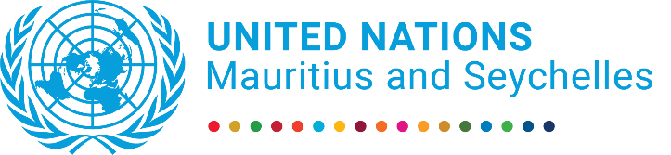

Unity is Strength
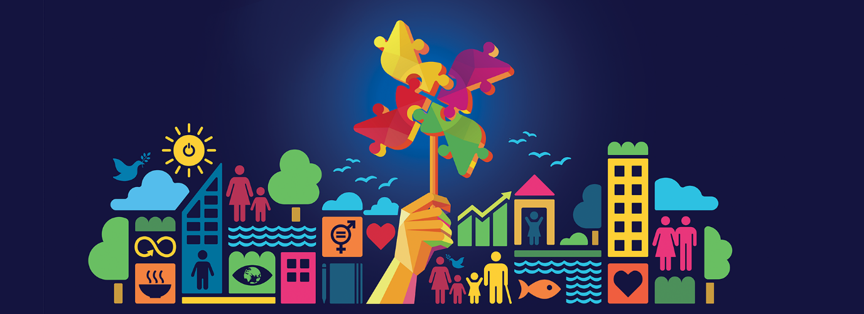

UN Joint Initiatives and their impact 2017-2022

Contents
LIST OF ACRONYMS 0
FOREWORD 0
INTRODUCTION 1
DISASTER PREPAREDNESS AND RESPONSE 3
- Capacity for Disaster Risk Initiative (CADRI) 3
- UN joint response to COVID-19 CRISIS 0
- Joint UN Response to the Wakashio Oil Spill disaster 1
GREEN, INCLUSIVE RECOVERY AND RESILIENCE 0
- The UN partnership on green recovery (PAGE) 0
- Support to food systems summit, National Dialogues, and national food systems pathways 1
- Southern African Migration Management project: Recovery and decent work 4
- Other joint programs - SDG fund projects on blue and green economy and Food Security 4
SDG ADVOCACY 6
- Voluntary National Review (VNR): 6
- The Multidimensional Vulnerability Index (MVI) 7
- SDG Planning 8
THE WAY FORWARD 9
- More joint initiatives as a coherent, systemic way of supporting Mauritius and Seychelles 9
- Transformative partnerships to deal with upcoming challenges 10

LIST OF ACRONYMS
CADRI | Capacity for Disaster Risk Initiative
DRM | Disaster Risk Management
DRR | Disaster Risk Reduction
FAO | Food and Agriculture Organization
FAREI | Food and Agriculture Research Extension Institute
GFDRR | Global Facility for Disaster Reduction and Recovery
GMCP | Global Maritime Crime Programme
GNDR | Global Network of Civil Society Organizations for Disaster Reduction
IAEA | International Atomic Energy Agency
ICJ | International Court of Justice
IFAD | International Fund for Agricultural Development
IFRC | International Federation of Red Cross and Red Crescent Societies
ILO | International Labour Organization
INFF | Integrated National Financing Framework
IOM | International Office for Migration
IMO | International Maritime Organization
JICA | Japanese International Cooperation Agency
NDRRMC | National Disaster Risk Reduction and Management Centre
NGO | Non-governmental organization
NOSCP | National Oil Spill Contingency Plan
OECD | Organisation for Economic Co-operation and Development
OHCHR | Office of the United Nations High Commissioner for Human
PAGE | Partnership for Action on Green Economy
SEIA | Socio-Economic Impact Assessment
SERP | Socio-Economic Response Plan
SGP | Small Grants Programme
SIDS | Small Island Developing State
SPF | Strategic Partnership Framework
UN | United Nations
UNAIDS | Joint United Nations Programme on HIV/AIDS
UNCT | United Nations Country Team
UNDAC | UN Disaster Assessment and Coordination
UNDESA | United Nations Department for Economic and Social Affairs
UNDP | United Nations Development Programme
UNDRR | United Nations Office for Disaster Risk Reduction
UNECA | United Nations Economic Commission for Africa
UNEP | United Nations Environment Programme
UNESCO | United Nations Educational, Scientific and Cultural Organization
UNFPA | United Nations Population Fund
UN-Habitat | United Nations Human Settlements Programme
UNICEF | United Nations Children’s Fund
UNIDO | United Nations Industrial Development Organization
UNITAR | United Nations Institute for Training and Research
UN-OCHA | United Nations Office for the Coordination of Humanitarian Affairs
UNODC | United Nations Office on Drugs and Crime
UNOPS | United Nations Office for Project Services
UNRC | United Nations Resident Coordinator
UNRCO  UNSDCF | United Nations Resident Coordinator’s Office  UNITED NATIONS SUSTAINABLE DEVELOPMENT FRAMEWORK
UN Women | United Nations Entity for Gender Equality and the Empowerment of Women
UNWTO | United Nations World Tourism Organization
WFP | World Food Programme
WHO | World Health Organization
WMO | World Meteorological Organization

FOREWORD
UNITY IS STRENGTH
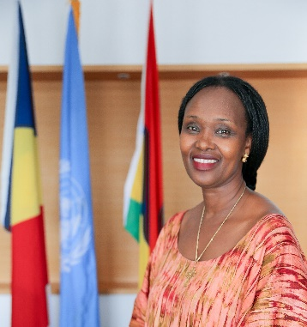
During the past two and half years, when the world faced an unprecedented emergency due to COVID-19, the UN Secretary-General António Guterres called for unity. “The pandemic should be a wake-up call. Deadly global threats require a new unity and solidarity,” he said.

The Pandemic started as health crisis and soon became a multidimensional social and economic challenge, resulting in the deaths of millions of people, severe economic fallouts, as well as loss of jobs and livelihoods. The UN described it as a human crisis. “The COVID-19 pandemic is a public health emergency — but it is far more. It is an economic crisis, a social crisis and a human crisis that is fast becoming a human rights crisis”. UN Secretary-General António Guterres

Collective action is critical in tackling such global challenges which threaten progress towards achieving the SDGs. Joint work demonstrated during COVID-19 response, where governments and their partners world-wide were united in action, showcased the value of multilateralism and international cooperation. In Mauritius and Seychelles, the UN, government partners and other stakeholders provided a wide range of coordinated support to deal with the crisis, through COVID-19 health response plans and the joint socio-economic response plans.

The UN reform strengthened coordination, making the UN entities greater than the sum of their parts. This ensured the emergence of a new generation of UN Country Teams, centered on a UN Sustainable Development Cooperation Framework (UNSDCF) and led by the UN Resident Coordinator. Mauritius and Seychelles signed the strategic partnership frameworks (SPF) 2019-2023 for each country with the UN team made of 20 entities. By adopting a shared vision and joint programs under the SPF, the UN interventions are more impactful in support of the countries as they strive to achieve the SDGs.

This publication attempts to show some joint programmes and initiatives, implemented by the UN as part of the current SPFs, under the following areas– (i) Disaster risk preparedness and response, (ii) Partnership for green recovery and resilience, (iii) and Joint SDG advocacy in the context of the Multidimensional Vulnerability Index (MVI) for the Small Island Developing States (SIDS).

It is by no means an exhaustive account of the UN work over these past few years; nor does it speak to individual UN agencies work, rather, it seeks to provide an overview of specific joint programmes implemented by two or more UN agencies, demonstrating UNity in action.

Promoting coordination, coherence and joint action for SDGs is not only my duty it is my passion.

UN Resident Coordinator
Muti-Country Office Mauritius and Seychelles

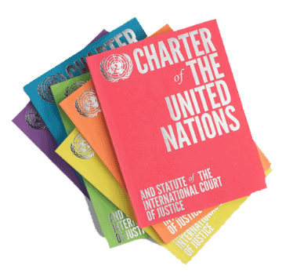
INTRODUCTION
The United Nations (UN) was formed in 1945 after the Second World War and is guided by the principles in its charter to promote peace and security, friendly relations among nations based on sovereign equality of states, human rights, social progress, and better standard of leaving.

The UN has supported efforts to deal with global challenges including conflicts prevention, peace building, humanitarian action, human rights, and development work in many countries. However, there are still pressing challenges facing the world, including climate change, natural disasters, wars, food crisis and raising oil prices.
The UN general assembly adopted the sustainable development goals (SDGs) and agenda 2030 as a blueprint to enhance peace and prosperity for people and the planet and as a call for action to transform the world by ending poverty and inequality, protecting the planet, ensure, justice, health, and prosperity for all while leaving no one behind.
To respond to specific needs of countries, the UN created specialized agencies, funds, and programs with various mandates to support national efforts to implement the SDGs. The UN team in each country operates through a consolidated UN/Government cooperation framework.
Mauritius joined the UN on 24 April 1968 and Seychelles joined the UN on 21 September 1976 soon after each country’s independence. They are active members of the UN and important partners in development. The UN/ government partnership with both countries has evolved over the years as they graduated to high income status. Most of the support includes technical assistance, policy advisory services and some programme support to their national priorities in line with regional and international commitments.
The UN reform was launched in 2019 with changes in the areas of Development, Management, and Peace and Security. In terms of development and in line with the SDGs, the reform has established a new generation of UN Country Teams, centered on a UN Sustainable Development Cooperation Framework (UNSDCF) and led by an independent and empowered Resident Coordinator system.
The multi-country office (MCO) for Mauritius and Seychelles is made of the following 20 UN Head of Agencies, funds, and programs, signatories of the UN/Government Cooperation Framework for each country and coordinated by the UN Resident Coordinator.
- Food and Agriculture Organisation (FAO)
- International Atomic Energy Agency (IAEA)
- International Fund for Agricultural Development (IFAD)
- International Labour Organization (ILO)
- International Organization for Migration (IOM)
- Joint United Nations Programme on HIV/AIDS (UNAIDS)
- Office of the United Nations High Commissioner for Human Rights (OHCHR)
- UNDP-GEF Small Grants Programme (SGP)
- United Nations Development Programme (UNDP)
- United Nations Economic Commission for Africa (UNECA)
- United Nations Educational, Scientific and Cultural Organization (UNESCO)
- United Nations Entity for Gender Equality and the Empowerment of Women (UN Women)
- United Nations Environment Programme (UNEP)
- United Nations Human Settlements Programme (UN-Habitat)
- United Nations Industrial Development Organization (UNIDO)
- United Nations Office on Drugs and Crime (UNODC)
- United Nations Population Fund (UNFPA)
- United Nations World Tourism Organization (UNWTO)
- World Health Organization (WHO)
- United Nations International Children’s Education Fund (UNICEF)
The UN Sustainable Development Cooperation Framework (UNSDCF) is the most important tool for planning and implementing activities at country level. It is aligned to national priorities and guided by the SDGs. It stipulates the UN contribution to a given country’s vision. It consolidates the work of the UN system in one framework providing a platform for common policy work, stronger coordination of programmes, and timely delivery of results.

The current cooperation framework between the UN and Government of Mauritius - United Nations Strategic Partnership Framework (SPF) 2019-2023, focuses on the following outcome areas: i) Transformed business ii) Ageing society and health and labour market reforms iii) Ocean economy and tourism iv) Inclusive, quality education and skilling, v) Social protection and gender quality and 6) Resilience to climate change

The current cooperation framework between the UN and Government of Seychelles – the UN Strategic Partnership Framework (SPF) 2019-2023, focuses on the following outcome areas: i) Blue Economy ii) Agricultural, food and nutrition security, iii) Natural resources, environment, disaster, and climate change, iv) Health, education, and skills and v) Data and technology.

The cooperation frameworks (SPF) 2019-2023 are implemented by UN agencies through various programs some of which are undertaken individually or jointly. This publication will focus on the following selected UN Joint Programs and initiatives where three or more agencies work together to carry out a program or initiative.
- Disaster risk preparedness and response,
- Capacity for Disaster Reduction Initiative (CADRI)
- Joint UN COVID-19 response (Health and Socioeconomic)
- Joint UN response to the Wakashio oil spill crisis
- Voluntary Review of the SENDAI framework
- Green recovery and resilience
- The partnership for green economy (PAGE) Green recovery
- Food systems summit, dialogues, and national food systems pathway
- Southern African Migration Management Project: Recovery and Descent work
- Joint SDG fund project on (blue and green economy)
- Joint SDG fund project on food security
- Joint Program on HIV
- Study on drug abuse by the high-level committee on drugs
- SDGs advocacy
- Voluntary national review on SDGs (VNR)
- Study on system thinking and SDG long term planning
- Multidimentional vulanbility study (MVI)
- UN/Government policy dialogue
- Global Compact on SDG by private sector
- Development Partner’s Group (DPG)
- UN/Government celebrating UN@75

DISASTER PREPAREDNESS AND RESPONSE
Mauritius and Seychelles, due to their structural constraints as Small Island Developing States (SIDS)- which include small land area and population, overreliance on strategic imports such as food and fuel, high concentration of exports and investments, low-lying coastal areas, fragile ecosystems, etc. - suffer from higher than average vulnerability to exogenous shocks.
Due to these vulnerabilities as SIDS - both countries are highly exposed to climate change and extreme weather events, including cyclones, floods, and tsunami, natural disasters such as oil spill, exogenous shocks, pandemics like the Covid-19, raising food and oil prices, amongst others. Hence, they are always looking for ways to continue strengthening their capacities in preparedness and respond to disasters, to build resilience and continue progressing on the sustainable development path.

Capacity for Disaster Risk Initiative (CADRI)
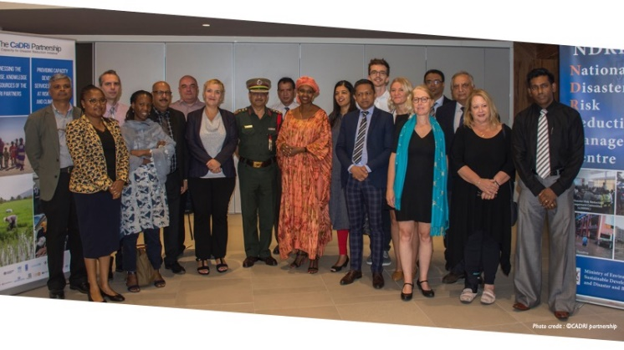
The UN supports countries to deal with disasters, enabling them to improve the ways to prepare and respond to emergency situations in a more coordinated way. Mauritius and Seychelles have also partnered with the UN system to enhance capacities for disaster risk reduction and response. For example, at the request of the government of Mauritius a comprehensive assessment for disaster risk was carried out in 2019, under the Capacity for Disaster Risk Initiative (CADRI).
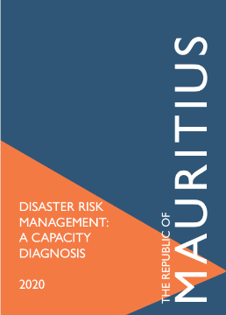
The capacity diagnosis of the disaster risk management (DRM) system, the CADRI’s assessment in Mauritius, was carried out in a participatory manner, with representatives of the central and local Government, civil society, the private sector, and bilateral and multi-lateral agencies. It identified existing capacities, key challenges, capacity gaps for six sectors – tourism, environment, agriculture, water and sanitation, health, and education (with infrastructure development being treated as a cross-cutting issue) and formulating recommendations for improved resilience.
Inset
Teamwork: 14 UN agencies are part of CADRI initiative
CADRI is made of 14 UN agencies: Food and Agriculture Organization (FAO), International Organization for Migration (IOM) United Nations Development Program (UNDP), United Nations Population Fund (UNFPA), United Nations children’s Fund (UNICEF), United Nation’s Office for Humanitarian Coordination (UN-OCHA), United Nation’s Education Scientific and Cultural Organization (UNESCO), the United Nations Office for Project Services (UNOPS), the World Food Program (WFP), World Health Organization (WHO) and the World Meteorological Organization (WMO); the United Nations Office for Disaster Risk Reduction (UNDRR), UN Women, and the United Nations Institute for Training and Research (UNITAR); plus two financing partners, namely the Grand Duchy of Luxembourg and the Government of Sweden and other partners like International Federation of Red Cross and Red Crescent Societies (IFRC), the Global Facility for Disaster Reduction and Recovery (GFDRR), the Global Network of Civil Society Organizations for Disaster Reduction (GNDR), and the Organization for Economic Cooperation and Development (OECD), among others.
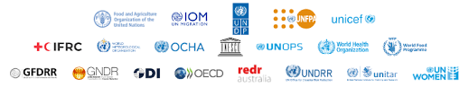

INSET:
“The capacity diagnosis is derived from a self-assessment by country stakeholders of the strengths and weaknesses of the DRM system at national and local level across socio-economic sectors. Information is collected from interviews of country stakeholders (government, districts and municipalities, private sector, civil society) and desk review of reports is triangulated by the CADRI Partnership team”.
The CADRI report and recommendations were immediately put to test by the outbreak of the COVID- 19 and the Wakashio oil spill. The information in the Mauritius CADRI report was used in different ways by Government including the production of the Disaster Risk Preparedness and Response plan as well as the national disaster risk reduction strategy 2020-2030. The UN also provided technical assistance to NDRRMC to follow up the implementation of the National Disaster Risk Reduction and Management Action Plan 2020-2030, including putting together an implementation strategy identifying priority actions to better predict and manage risks - including plans for a geographic information system infrastructure, national spatial data infrastructure and automatic weather systems - was put elaborated.
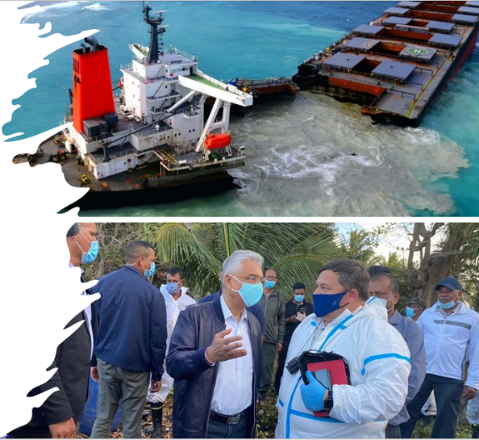
Several Ministries were supported in incorporating DRR in their sectoral policies, such as the new National Land Development Strategy, the Environment Masterplan, and the revised Environment Protection Act and updating the country’s National Oil Spill Contingency Plan (NSOCP). Line Ministries were sensitized on the importance of developing their own DRR sectoral strategies using the Mauritius CADRI report. This helped to profile of DRR at various levels of Government including support on urban resilience and training in disaster risk management for municipal and District Council employees.
By working through joint Programmes a wide range of expertise and resources from the relevant UN entities, both based in-country and from regional and global levels, the UN Family in Mauritius and Seychelles therefore continues to provide wide-ranging support for DRR capacity building to increase the country’s resilience to disasters of various natures.
For example, joint programs on Geospatial Information Technology (GIT) for Operational planning and Decision-making in Disaster Risk Management are organised by UN (UNITAR and UNDRR) and the Indian Ocean Rim Association (IORA). The UNDRR is also contributing to the Resilience Building and Disaster Risk Management in the Indian Programme (RDRM-IO) Programme, which aims to reduce disaster and climate related losses, build governance capacities in member States of the Indian Ocean Commission, namely Comoros, Madagascar, Mauritius, and Seychelles. In addition, the UNDRR assisted Mauritius and Seychelles in preparing their midterm Review for the Sendai framework for Disaster Risk Reduction (2015-2030). Each country is supposed to check progress on the implementation of priority targets and actions in terms of disaster risk reduction.

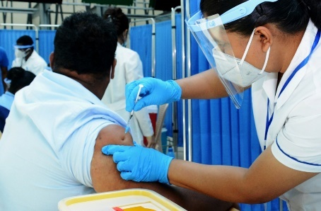
UN joint response to COVID-19 CRISIS
Response to COVID-19 crisis was an important demonstration of the UN united in action. The UN System jointly played a crucial role, at national and international levels, during the pandemic. In Mauritius and Seychelles, from the outset, under the leadership of the UN Resident Coordinator, UN agencies adapted very quickly, and repurposed their program resources to respond to initial challenges.
WHO provided technical support to develop and implement the public health preparedness and response plan, UNDP contributed to health system strengthening through digital technology and social protection through the COVID Solidarity Fund. UNFPA supplied equipment for health workers and provided support to GBV survivors. IAEA contributed funds for purchase of special diagnostic kits. UNODC supported the supply of COVID-19 PCR testing kits and targeted guidelines on care for People Who Use Drugs and People Living in Prisons and closed settings. UNAIDS provided guidelines for people living with HIV, UNESCO worked with national commissions providing IT solutions, e-learning guidelines for children out of school due to COVID-19, and guidelines to fight disinformation. UNECA’s analytical work resulted in the first quick assessment of the socio-economic impact of COVID-19, IOM produced guidelines for border management and support of migrant workers. ILO acted as advocate for sustainable jobs and labor guidelines. UNWTO quickly assessed the impact of COVID19 on the tourism sector while OHCHR provided guidelines for respecting human rights during the pandemic. UNHCR implemented a COVID-19 Emergency and Refugee Assistance Project providing Personal Protective Equipment (PPE) and food to vulnerable people.
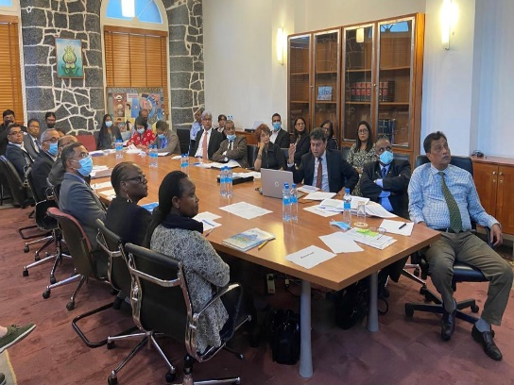
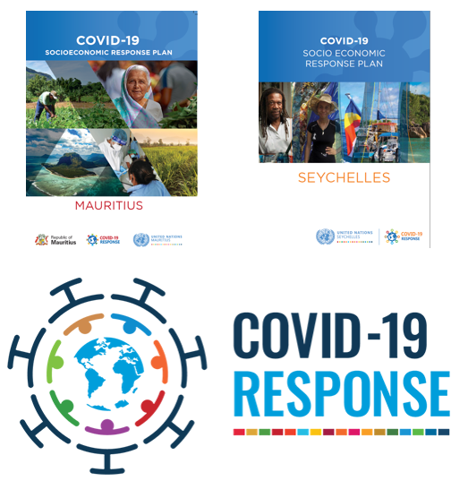
After an initial quick response focused on health and led by WHO, at the request of each government, the UN jointly developed the COVID-19 Socioeconomic Response Plans (SERP) using global guidelines, aligned to the strategic partnership framework of each country. The objectives of the plans were to assist each Government to look beyond health: to prepare for and protect people from the pandemic and its impacts, in the immediate term; to respond during the outbreak; and, in the medium to long term, plan for and implement recovery from socioeconomic impact.

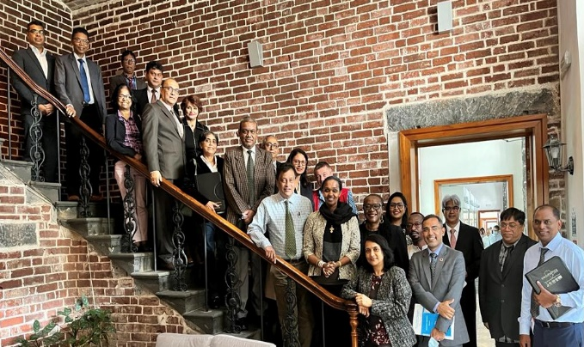
The SERP in Mauritius was implemented under the strategic leadership of the UN Resident Coordinator and the Prime Minister’s Office and in Seychelles under over all guidance of the UN resident coordinator and the foreign ministry in Seychelles. The technical lead UN agency was UNDP and Ministry of Finance from the government side.

The plan focused on three pillars:

"I see three critical areas for action:
First, tackling the health emergency.
Second, we must focus on the social impact and the economic response and recovery.
Third, and finally, we have a responsibility to recover better. "António Guterres Secretary-General of the United Nations

The UN joint COVID-19 social economic response plan for each country brought together several agencies including (UNDP, FAO, ILO, IOM, UNEP, UNESCO, UNECA, NFPA, UNHCR, FAO, IFAD, ILO, UNESCO, UN Habitat, UNIDO and UNWTO)

Joint UN Response to the Wakashio Oil Spill disaster
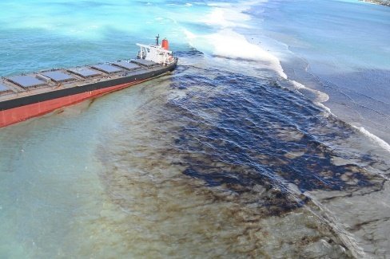
Oil spills are complex and difficult to manage, both in terms of dealing with immediate crisis and the aftermath; urgent and decisive action is essential in minimizing the impact of the disaster. Hence the rapid mobilization of the UN Family to support the Wakashio oil spill crisis, working in an efficient, coherent manner with the Government and other international agencies, was critical and a good example of the importance of coordination and joint action.
In 2020 when the bulk carrier MV Wakashio ran aground and started leaking fuel, threatening to damage the natural ecosystems and the livelihoods of coastal communities at the southeast coast near blue bay Marine Park and Pointe d’Esny, the government, declared a state of environmental emergency and requested support from development partners.
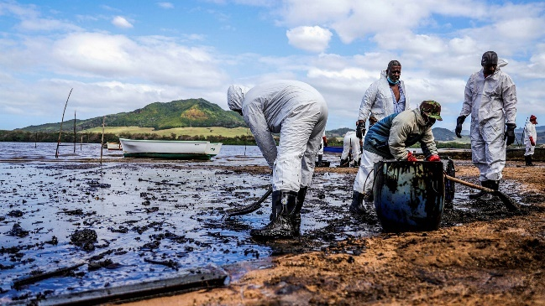
Within hours, the United Nations Resident Coordinator’s Office (UNRCO) for Mauritius and Seychelles, working with the Office for Coordination of Humanitarian Affairs (OCHA)’s regional office for Eastern and Southern Africa initiated a multiagency response team of experts made of OCHA’s crisis coordination and response specialists, UN Environment (UNEP) and the International Maritime Organization (IMO) experts in managing complex oil spills, IOM’s specialists in forced displacements and rapid needs assessment, UNODC’s specialists in maritime crime, and investigation, and a specialist to assess health implications of the oil spill to the community from WHO. Despite the global disruption in international air travel due to COVID-19, a flight was chartered from Nairobi from the World Food Programme (WFP) was able to quickly bring in the experts in record time experts specialized in managing complex oil spills.
In preparation for the team of UN external experts the UN entities and representatives in country had already started organizing and supporting the response from the Blue Bay Fisheries Office, the headquarters of the response in Pointe d’Esny.
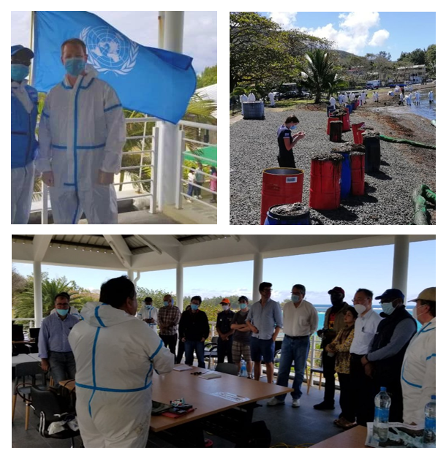
The UN set up and ran a field office that provided equipment and space for the UN experts, the international response team (Japan, France, UK, India) and for civil society and private sector actors that were involved in the response. The UN Resident Coordinator re-purposed her team to support OCHA and the specialized response teams in coordinating crisis meetings, promoting the integration of all relevant stakeholders in real-time needs assessments and decision-making, providing inputs to the government on crisis communication, and working to set up a system to monitor the disaster’s impact over time. UNDP and IOM supported the environmental and social impact assessment and monitoring support as well to communities, and the World Health Organization (WHO) backed government in surveilling the spill’s public health impact while UNODC offered additional help in forensic investigation and legal support. The entire UN Country team kept abreast of the situation through regular briefings. The UN regional directors team sent a representative (IOM Regional Director for Southern Africa region) to review the situation and offer high level solidarity, advocacy, and support. He also launched the Wakashio fund with H.E the President of the Republic and provided seed money to kick start it. The Wakashio oil spill fund was set up with contribution from the UN Regional Directors for Eastern and Southern Africa to support post disaster activities including environmental recovery and resilience, community livelihoods and environmental engagement, Maritime surveillance and enforcement of international practices, public health, coordination, communications, monitoring, and evaluation among others.

GREEN, INCLUSIVE RECOVERY AND RESILIENCE

The UNCT conducted, starting in August 2020, a series of multistakeholder reflections on models for a greener, more resilient, and more inclusive recovery, involving in-depth assessments by various UN entities on the impacts of COVID-19 on different sectors, knowledge exchange and sharing, and policy discussions.

The UN partnership on green recovery (PAGE)
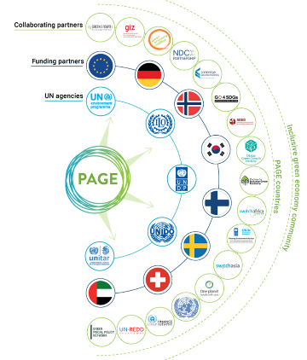
Throughout almost a decade of implementation in Mauritius until the country graduated in 2022, PAGE made the constant, widely acknowledged demonstration of what the UN can achieve through joint action. Five UN agencies – UNEP, ILO, UNDP, UNIDO and UNITAR – worked together, shared knowledge and tools, provided policy advice, supported strategic planning and spurred transformative partnerships and capacity building to leverage collective strength and accelerate progress towards inclusive, green, and sustainable development.
Mauritius joined the PAGE in 2014. The overarching objective was to help the country in “its efforts to transition to a low carbon economy” by supporting its contribution to five goals of the SDGs, namely No Poverty (1); Decent Work and Economic Growth (8); Industry Innovation and Infrastructure (9); Climate Action (13); and Partnerships for the Goals (17).
PAGE achieved critical, impactful results, installing an enabling legal and policy environment, building human and institutional capacities, fostering intersectoral coordination arrangements and mobilizing resources to boost the transition towards a green economy.
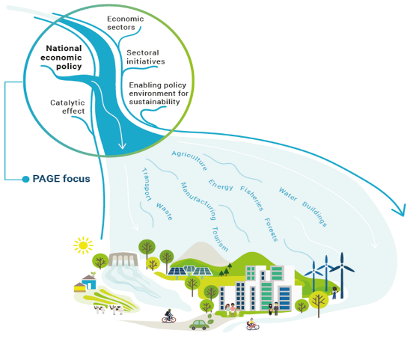
PAGE provided direct support to Mauritius’ Marshall Plan Against Poverty and Exclusion, which led to the creation of the Marshall Plan Social Contract for providing financial assistance to low-income families.
Following the COVID crisis, PAGE was reinforced with emphasis on building a green and inclusive recovery to enhance resilience.
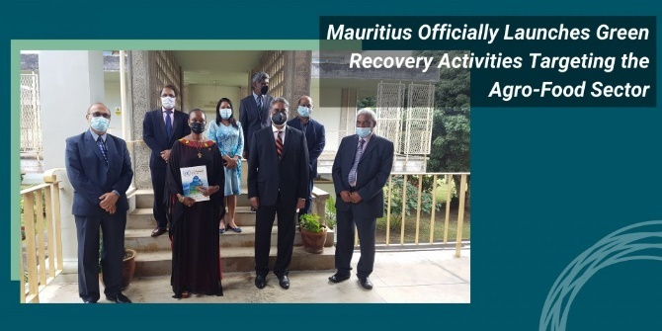
Funded through the German Federal Ministry of the Environment, Nature Conservation and Nuclear Safety, the PAGE Green Recovery Fund was officially launched in June 2021. The key objectives of this technical support programme consisted of improving the business environment and developing incentives needed to promote a sustainable agrifood industry namely by supporting the expansion of Small and Medium Enterprises (SMEs) in the sector.
As part of its mission of complementing the country’s green recovery through the development of a sustainable agriculture, the PAGE Green Recovery Fund, in collaboration with the Ministry of Agro-Industry and Food Security and the Food and Agriculture Research and Extension Institute (FAREI), created macroeconomic models to help forecast green job creation in the food production industry, as well as a diagnostic and rapid assessment toolkit to promote public and private funding “for nature based solutions and smart agriculture that will support sustainable food systems”.
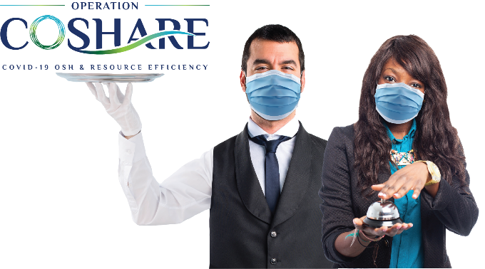
In addition to supporting the transition to a greener agricultural model, the PAGE Green Recovery Fund also supported efforts to help Mauritius become a safe destination for travellers to ensure that the tourism industry would be ready to welcome visitors as soon as the borders opened. PAGE set up jointly with the Ministry of Tourism, the National Productivity and Competitiveness Council and the Tourism Authority, Operation COSHARE (COVID-19 Operational Health and Safety and Resource Efficiency) which was “designed to enhance the capacity of employees in the sector through the promotion of health standards and protocols”.
Inset
Launched in September 2021, Operation COSHARE worked with the many teams in tourism sector, including tourism operators – hotels, restaurants, leisure service providers, taxi drivers, destination management companies, etc. – to position Mauritius “as a safe and environmentally sustainable tourist destination, attracting foreign visitors to make Mauritius their destination of choice — overall helping the industry recover from the economic impacts of the pandemic”. The project also looked at minimizing the environmental waste created by the pandemic, such as single use plastics and chemicals.

Support to food systems summit, National Dialogues, and national food systems pathways
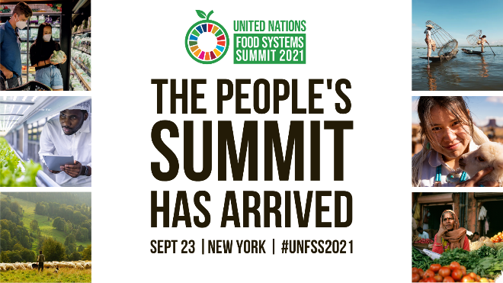
Ahead of the UN Food Systems Summit, which was convened by the UN Secretary Secretary-General António Guterres as part of the Decade of Action to achieve the Sustainable Development Goals by 2030, member States were invited to host their own National Food Systems Dialogues as a way of identifying “national pathways to sustainable food systems and expressions of intention to support these pathways from a broad range of stakeholders, providing opportunities for these stakeholders to engage in preparations for the Summit through structured interactions”.
Mauritius and Seychelles imports almost 80% of the food consumed, making food security a major issue. These challenges are further compounded by internal and external factors such as climate change, underdeveloped value chains, insufficient access to finance, weak land tenure systems and a lack of awareness about the complementarity of bilateral and multilateral actions.
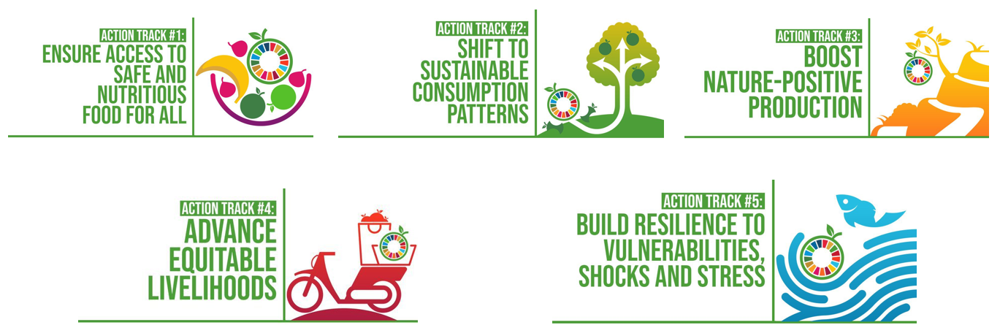
Facilitated by UN RCO, two UN agencies FAO and IFAD jointly worked to support both Governments to undertake National Dialogue on Food Systems which were launched 2021. Their exchanges and findings were compiled into country reports that form the basis of the “pathway for green, fair and more resilient food systems in Mauritius and Seychelles” which each country presented at the UN Food Systems Summit (UNFSS) in New York in September 2021.
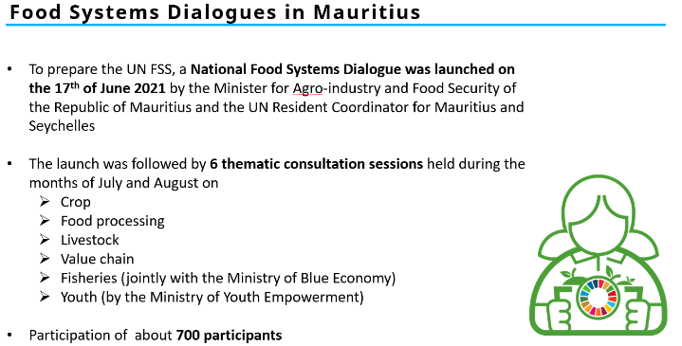
In Mauritius
This dialogue regrouped 700 participants from across Government, the UN System, the private sector, and civil society, provided a valuable platform for stakeholders involved in food production in Mauritius to discuss a raft of vital issues pertaining to crop production, agro-processing, livestock, fisheries and value chains, amongst other things.
Their exchanges and findings were compiled into a country report that forms the basis of the “pathway for green, fair and more resilient food systems in Mauritius” which were presented at the UN Food Systems Summit in New York in September 2021.
The country report lays out a series of potential outcomes and recommendations to promote sustainable food systems, local crop production, climate change adaptation and mitigation measures, the use of new technology, land management and livestock farming. The report also proposes actionable solutions for sustainable growth.
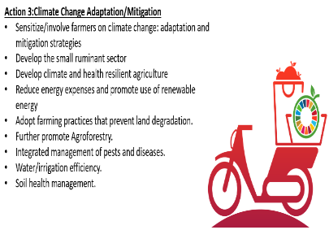
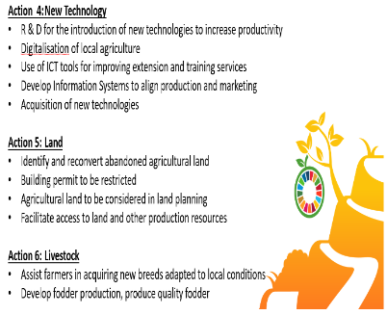
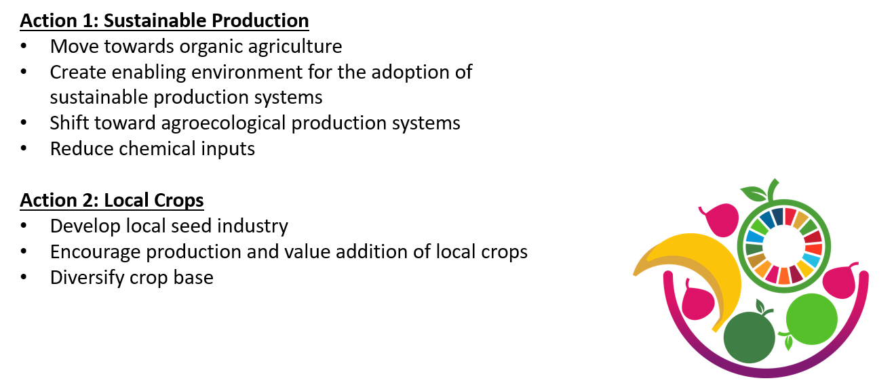
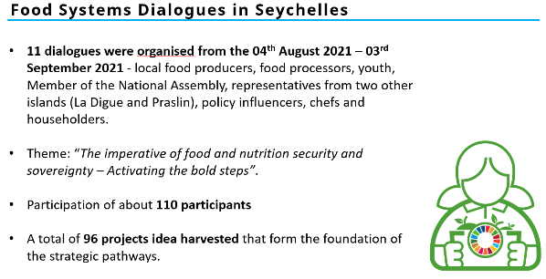
In Seychelles
These 11 dialogues with 110 participants were organised from local food producers, food processors, youth, members of national assembly, representatives from three main islands (Mahe, Praslin and La digue), policy influencers, chefs, and members from different households.
96 project ideas were harvested that form the foundation of pathways which were compiled into a country report under the theme “food and nutrition security and sovereignty, activating the bold steps in Seychelles” which was presented at the UN Food Systems Summit in New York in September 2021.
The country report lays out a series of potential outcomes and recommendations to promote sustainable food systems, local crop production, climate change adaptation and mitigation measures, the use of new technology, land management and livestock farming. The report also proposes actionable solutions for sustainable growth.
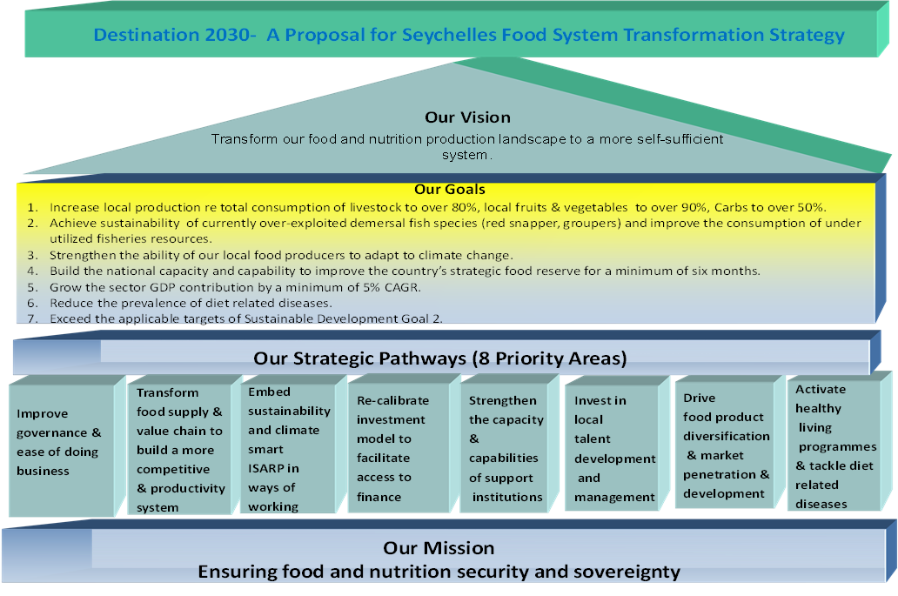

Southern African Migration Management project: Recovery and decent work
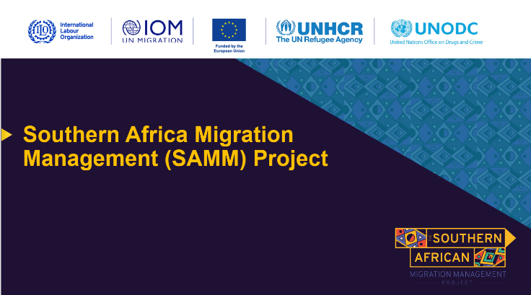
The Southern Africa mixed migration project (SAMM) is a four-year program running from 2020-2024 which at aims at improving migration management in the Southern Africa and Indian Ocean region. It is multi-agency joint project which brings together four agencies including: – International Labour Organization (ILO), International Office for Migration (IOM), UN High Commissioner for Refugees (UNHCR) and UN Office on Drugs and Crime (UNODC). Underpinned by Goals 8 and 10 of the SDGs (Decent Work and Economic Growth, and Reduced Inequalities, respectively), SAMM focuses on two types of migration, namely labour migration, and mixed migration. This UN joint program focuses on people’s welfare as the main goal of crisis response; it emphasizes that recovery demands a Human Rights-based approach, where the most vulnerable are empowered to build resilience and enjoy enhanced access to their rights, to quality services, and to economic opportunities. Migrants are often amongst these vulnerable populations, and the Southern African Migration Management (SAMM) project aims to support them to enjoy dignified lives.
The project’s strategic objective in terms of labour migration is to create an improved labour policy environment for labour migration across the region and improved access to legal and efficient means of labour mobility for (prospective) labour migrants. This includes the setting up of gender-sensitive policies, international labour standards, circular migration agreements, fair recruitment policies, and social protection of migrant workers.
Mixed migration, on the other hand, refers to “complex migratory population movements that include refugees, asylum seekers, victims of trafficking, migrant workers and other migrants, as opposed to migratory population movements that consist entirely of one category of individuals”. The project aims at strengthening management of mixed migration flows, including improved protection of vulnerable migrants in the Southern African and Indian Ocean region. To achieve this, SAMM is advocates for the adoption of UN Conventions addressing the treatment of refugees, governance of mixed migration flows and awareness campaigns on the benefits of safe migration, amongst others. Given that climate change is expected to increase migration flows, strategies were also put in place to ensure right policies and structures to deal with this challenge.

Other joint programs - SDG fund projects on blue and green economy and Food Security
The Joint SDG Fund is a key part of the United Nations Systems reform of the UN’s development work and it provides the financial means to Resident Coordinators (RCs) and UN Country Teams (UNCTs) to boost SDG implementation by working together on key accelerators such as social protection, development finance, economic development or food systems.
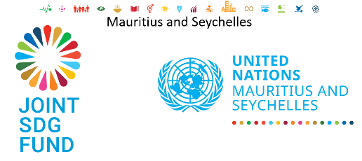
The two projects financed by the SDG Fund in Mauritius and Seychelles encompass the very spirit of the United Nations Reforms, which is about partnerships and an integrated approach. First, they bring together six UN Agencies: UNEP (Lead), UNDP, UNECA, ILO, IOM, and UNFPA for the SDG Fund on Blue and Geen Economy, and FAO, UNDP and UNWomen for the project on Food Systems. These agencies collaborate towards a common goal, bringing their respective strengths and expertise to secure a transformative results contributing to key national priorities. Resources being scarce, especially for middle- and high-income SIDS like Mauritius and Seychelles and by coming together agencies are maximizing the available resources and ensuring coherence in action for greater impact.
While Mauritius and Seychelles have their own specificities, SIDS share the same challenges. The SDG Fund projects are also a unique opportunity for the two countries to further their collaboration, looking into innovative solutions to shared challenges. The two countries have indeed the opportunity to learn from each other’s activities and best practices, paving the way for the development of joint solutions.
Finally, these projects will spur collaboration amongst all key stakeholders of sustainable development in both countries – Government, Civil Society and the Private Sector. They feature Steering Committees that brings on the one hand stakeholders from the two countries but also members from the public sector, the private sector, academia, and civil society. This is the very embodiment of the participatory approach that the UN advocates for.
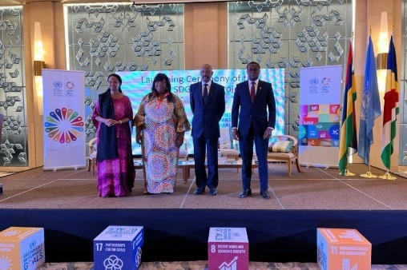
The first project, “Contributing to establishing an enabling environment to promote sustainable Green and Blue Economy” will support the Government of Mauritius in accelerating the country’s energy transition by boosting the deployment of Ocean Renewables; and the Government of Seychelles, in enhancing solid waste management by promoting the circular economy and encouraging what experts call “from cradle to grave” initiatives and projects.

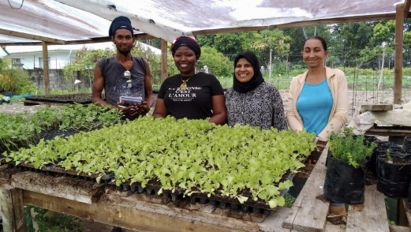
The second project, “Building the resilience of Food Systems by leveraging on Sustainable Agricultural Practices”, intends to supports efforts towards food security and mitigating the countries’ overreliance on food imports (90% in Seychelles, 70% in Mauritius) and external inputs for food production, by supporting the country to produce low-cost bio-fertilisers from seaweeds. This will reduce the vulnerability of Mauritius food systems to external shocks. The project also places a strong emphasis on gender equality and women empowerment in the agricultural sector. In Seychelles, the project is promoting the use of climate smart agricultural methods and approaches, such as aquaponics, hydroponics and sheltered farming, helping smallholder farmers and households to increase the production of local food and reduce reliance on imported products.
"UN Country Teams are using the Development Emergency Modality of the Joint SDG Fund to help governments devise strategic interventions to cope with the multi-dimensional crisis in food, energy, and finance, and accelerate the transformation of food systems." Amina Mohammed United Nations Deputy Secretary-General

SDG ADVOCACY
Almost midway through the SDG path, and in times where multiple crises are diverting population and policy attention and public and private investments from longer term sustainable development objectives, it is critical for countries not to lose focus on transformations urgently needed to ensure inclusion, build resilience, and advance development and human rights. This is the role of the UN, of all agencies together, to accompany the member States striving to combine short-term response and long-term transformative action. Hence SDG-based advocacy not only remain a current need, but became also a urgent one. IN Mauritius and Seychelles, the United Nations agencies supported together, in this sense, the elaboration of the Voluntary National Review, the development of a global Multidimensional Vulnerability Index led by Small Island Developing States, as well as SDG planning and private sector engagement.

Voluntary National Review (VNR):
The UN system supported Mauritius and Seychelles in the preparation of their first Voluntary National Review (VNR) report on the SDGs, in 2019 for Mauritius and in 2020 for Seychelles.
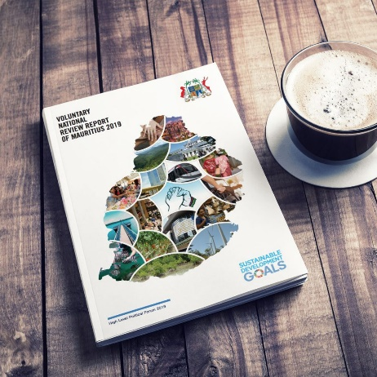
Amongst the key messages of its VNR, Mauritius stressed that over the past fifty years, the country has pitched its development around the building of Partnerships. The collaboration between Civil Society, the Public and Private sectors and academia in Mauritius is exceptional and has allowed the pursuit of a people focused development and has consolidated social cohesion. Hence Mauritius’ VNR, which involved a close consultative process with different stakeholders, shows this national partnership is working. The country has built similar partnerships at bilateral and regional levels.
The VNR also stresses the need for more resilient infrastructure in face of climate change effects such as flashfloods, the sustenance of a welfare system in the face of an ageing population or the need for more funds to build capacity, all speak to the challenge of being a middle income country without easy access to grants or concessional loans.
Seychelles’ VNR recall that For Seychelles, the VNR process immediately followed the launching its Vision 2033 and National Development Strategy (NDS) 2019 – 2023. Developed by means of broad public consultations the two national documents stipulates the medium to long-term pathway to sustainable development for the country based on the national priorities. It also allowed for the mapping of the SDG’s onto the six thematic pillars thus ensuring that the enabling environment which is imperative for implementation is provided for.

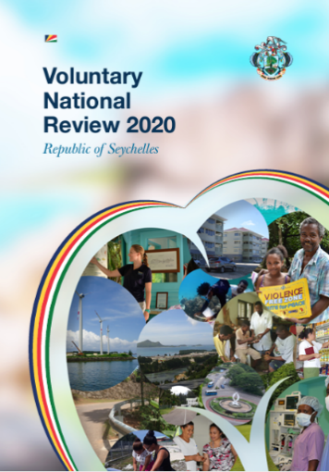
The VNR stresses that the preamble of the Constitution of Seychelles, states that Seychelles will “develop a democratic system which will ensure the creation of an adequate and progressive social order guaranteeing food, clothing, shelter, education, health and a steadily rising standard of living for all Seychellois”. It is against this background that the sustainable development goals are being implemented.

Finally, Seychelles’ VNR acknowledges that the Sustainable Development Goals are interrelated and cannot be achieved by Government alone which is why the partnership domestically with the private sector and civil society is of utmost importance.

Both VNRs stress that global partnerships have a catalytic role to play for Mauritius and Seychelles to successfully advance its SDGs as part of its broader national agenda that encompasses the African Union’s Agenda 2063, the Samoa Pathway or the African Peer Review Mechanism.

Both VNRs also mention that Mauritius and Seychelles were the first to make a joint submission on the sharing of maritime space whilst at regional level, they host yearly a Conference with the
Indian Ocean Commission to build Partnerships around a maritime agenda.
Following this milestone, the country asked for UN assistance to more effectively integrate the multi-dimensional aspects of the SDGs into its national planning process.

The Multidimensional Vulnerability Index (MVI)
As mentioned above, structural constraints of SIDS condition a higher-than-average vulnerability. These vulnerabilities are hurdles on the pathways towards the 2030 Agenda and exacerbate impact of exogenous shocks. To build resilience and accelerate pathwqys towards sustianable development and the Agenda 23030, profound transformations are ongoing in SIDS, which must accelerate and be fueled by partnerships and finance. Since the Rio Conference in 1992, SIDS have been advocating for an MVI, and several were developed, with no consensus. Yet, following COVID’s overwhelming impact on vulnerable countries, a UNGA resolution (75/215) asked for a UNSG report. The SG report requested the finalization of the MVI led and driven by member States through a High-Level Panel of Experts.
The MVI’s main objectives are to raise awareness and reinforce access to partnership and finance for SIDS, based on the evidence of their vulnerabilities. The MVI will serve to measure the degree of structural vulnerability of SIDS. This will help to identify differences in terms of structural vulnerability across SIDS regions, and therefore to understand the relationship between structural vulnerability and the achievement of the SDGs. The MVI will then allow to shed a new light on the targeted financial mechanisms and development pathways needed to achieve resilience and the SDGs.
The MVI will be used as an advocacy instrument to:
- Serve as an advocacy tool to promote the principle to Leave No One Behind
- Foster evidence-based decision-making and the development of smarter, risk-informed national, bilateral and multilateral cooperation (including SIDS-to-SIDS)
- Inform United Nations and partners in-country engagement and support the preparation of country graduation strategies
The MVI will also be used as a measurement tool to design and implement evidence-based policy solutions by:
- Informing action to address vulnerability and build in-country resilience (evidence-based policies and partnerships);
- Facilitating evidence-based, targeted and effective support and smarter resource allocations
- Serving as a tool for monitoring, evaluation and measuring vulnerability and targeted policies to leave no one behind
- Supporting and guiding the formulation of country vulnerability resilience profiles
Finally, the MVI will be used as a complementary tool to access partnerships and concessional finance, including climate finance, by:
- Being a companion to the GDP and complement performance-based allocation models, allowing the use of a vulnerability component
- Guiding the design of innovative financing mechanisms and act as a vehicle for providing exemptions or wider eligibility regarding the rules governing access to development and concessional financing.
The UN system in Mauritius and Seychelles participated, together with the UN systems in other SIDS, in the elaboration of the MVI. They are now supporting its finalization and its validation by the end of the year (2022). They also support advocacy to make all member States, but also organization such as the International Financial Institutions (IFIs), the OECD and other partners and creditors to accept it formally. They will then support, building on these efforts, the mobilization of financial and non-financial resources to build resilience and advance sustainable development.

SDG Planning

Midway through the SDGs and with multiple crises hampering their progress, bringing all stakeholders is both necessary and urgent, to boost transformative policy making and investments in a context of strong focus on crisis response and limited fiscal space.
Hence the UN Team strove to engage Government entities, civil society organizations, the academia and the private sector in a joint reflection on the sustainable development interconnected objectives, the pathways toward them, and the resources available and needed.
Acknowledging the integrated nature of the SDGS and the need to address crises and sustainable development challenges in a holistic manner, the UNCT mobilized expertise from the UN Department of Economic and Social Affairs (DESA) and UNITAR to support a process of integration of systems thinking into national approaches of sustainable development for long-term planning and policy integration.

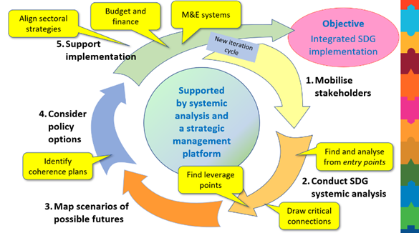
The experts and stakeholders involved analyzed past actions under similar (crisis) conditions, assessed current problems faced by the country, and identified policy opportunities – leverage points - for improving future performance towards sustainable development, on the on hand; and on the other hand use systems thinking to forecast the outcome of short-term actions on medium and long term development, and explore the use of different approaches to decision making at a time for crisis.
These policy opportunities or leverage points in turn demand partnerships and investments, sometimes through public private partnerships or at least in coherence between public and private sectors, and between domestic and external investments.
To better understand the different financing flows them towards common sustainable development objectives as defined by the national priorities and the SDGs, the UN is supporting SIDS, among others, in developing Integrated National Financing Frameworks (INFF) to align financing policies/tools to National Priorities and catalyze financing to advance the SDGs. It was agreed that agencies can combine efforts to support government of Seychelles to join efforts of other SIDS and develop its own INFF. Discussions started in Mauritius to undertake the same process.
Private sector is indeed a critical player in sustainable development, and a potential game-changer for SDGs achievements. Involving all UN Agencies, the Global Compact Mauritius and Indian Ocean serves as a catalyser on SDG action by private sector. In both countries the private sector has joined global compact to advocate for SDGs.
Celebrating the UN 75th Anniversary in both countries was an opportunity to mobilise the youth to discuss their aspirations for the future during the decade of action

THE WAY FORWARD

More joint initiatives as a coherent, systemic way of supporting Mauritius and Seychelles
Mauritius and Seychelles have done well on their development path, reaching a high level of human development, most of its population has access to quality education, good health services, and sufficient income to live decently.
However, as a Small Island Developing States, these counties face structural constraints and vulnerabilities, making the islands highly vulnerable to external shocks, whether they are socioeconomic or environmental.
Mauritius and Seychelles are addressing these challenges through innovative pathways and alternative solutions to reduce overreliance on food and energy imports, diversify economy, build transformative partnerships, in ways that lead to sustainable development. While finding innovative ways to finance their development since both countries are high income with limited access to development aid.
The whole of UN approach is needed to support these national efforts. In Mauritius and Seychelles, over 20 UN agencies provide support on issues as diverse as health, the environment, education, disaster risk reduction and climate change adaptation, Human Rights, sustainable industrialization, and the strengthening of food systems. Coherency and focus make the wealth of UN expertise and convening power more impactful in efforts to achieve sustainable development.
To achieve this objective, in the context of the UN Reform, the UN Family and government co-developed the strategic partnership framework SPF 2019-2023 as a first step towards a more integrated approach to support development. Going forward the new cooperation framework needs to be developed the UN Sustainable development framework (UNSDCF) 2024-2028 based on which joint programs of the UN will be designed and country program documents of individual UN agencies will be derived.
Box 3: The UN’s integrated approach in supporting the Governments of Mauritius and Seychelles
The Strategic Partnership Frameworks 2019-2023 already helped link the work of the UN agencies by aligning their contributions to the long terms needs of Mauritius and Seychelles. Setting up such a framework was an important first step for the UN to better coordinate its interventions as well as for the Governments to better understand how the contributions of the entire UN System could serve its long-term development goals.
In practice then, by implementing the activities listed under the Strategic Partnership Framework, the need for and the value of multisectoral, integrated work became obvious.
The various joint programs under disaster risk management, Wakashio oil spill response, COVID response, green recovery, food systems pathway and many others show that the UN joint efforts to conduct analysis, develops strategies and legislation, policy formulation as well as training and capacity building is important to support nation development efforts.
Individual UN agencies support are also critical because agencies country program documents are aligned to the UN/government cooperation framework contribution to same outcomes and national priorities.
The UN support is not restricted to brick-and-mortar types of projects but encompasses high level policy support and brings together UN global experience as well as access to knowledge and solutions. It is important therefore to build on this partnership to shape the future together.
Going forward the UN and government cooperation framework UNSDCF 2014-2028 must follow the same pattern to bring the UN efforts together to support national development.

Transformative partnerships to deal with upcoming challenges
Building on UN/Government Seychelles Policy Dialogue and the UN/Government of Seychelles Policy Dialogue it is critical to continue the high-level dialogue with the Governments of both countries on lessons learnt from the crisis period and priorities looking forward, informing the design of the new cooperation framework.
Strengthen International Partners coordination will also be of the essence, building on the informal coordination which prevailed during COVID and Wakashio crisis to embed it in a clear institutional framework with Government leadership and active participation from all development partners and International Financial Institutions.
One major lesson the UN System and our partners from Government, the private sector, and civil society can draw from the last couple of years is the necessity to be ready for crises. We need contingency plans that have both immediate, medium-term, and long-term elements, and we need standing partnerships to ensure that we can respond rapidly to crises, and that our responses do not divert from our long-term development objectives, but instead strengthen our resilience in preparation of future shocks.
In a rapidly changing development landscape characterized by high uncertainty, preparedness is of the essence, and the UN and its partners must stand ready to collaborate in responding to resurgences and new shocks, whether they are social, economic, environmental, or a combination of the three.
We must be able to prepare crisis scenarios, and design multi-sector mechanisms to respond to them in a manner that makes best use of the more than 20 UN entities in supporting the efforts of Government all national stakeholders.
We must also ensure that the new cooperation framework we will be preparing for 2024-2028 is fully risk-informed and integrates risk-preparedness and response as a cross-cutting element.
This way, the UN system will be ready, along with our development partners, to best support Mauritius and Seychelles to rapidly respond to any new crisis, in a way that remains aligned with the country’s long-term development objectives, including building resilience to sudden shocks and lasting stresses.
The agenda of resilience is no different from the Agenda 2030. By progressing towards the Sustainable Development Goals, and within this very journey transitioning towards a blue/green economy and sustainable energy and food systems, strengthening health, social protection and education systems, and ensuring universal access to basic services and make sure to Leave No One Behind, the countries will become more resilient to exogenous shocks, and its people less vulnerable.
We are now looking forward to working with Mauritius and Seychelles to strengthen our capacities to work in a more integrated manner, both to support national capacities to integrate the SDGs in national planning as well as to develop together a multisector UN-to-Government cooperation framework that is fully integrated and risk-informed.

UN FAMILY IN MAURITIUS AND SEYCHELLES

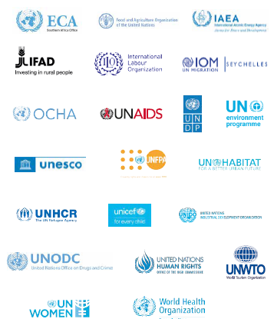

The Multi Country Office review concluded that Mauritius and Seychelles would be a Multi-Country Office (MCO)
More agencies or departments of the UN could be supporting the two countries who are not signatory to SPF
UNICEF is signatory to the Seychelles cooperation framework. Negotiations are underway for UNICEF to join CF for Mauritius
A Joint Program involves two or more UN agencies
Find more about UN’s work is on UN websites for an overview of the work of individual entities, annual reports, and a wealth of other documents with more information. https://mauritius.un.org/ https://seychelles.un.org/
The request was by Government through the National Disaster Risk Reduction and Management Centre (NDRRMC), operating under the aegis of the Ministry of Local Government and Disaster Risk Management presently (previously it came under the Ministry of Environment, Solid Waste Management and Climate Change).
CADRI is a global joint initiative of 14 UN entities, the International Federation of Red Cross, Red Crescent Societies (IFRC), the Global Facility for Disaster Reduction and Recovery (GFDRR), Global Network of Civil Society Organizations for Disaster Reduction (GNDR), and the Organization for Economic Cooperation and Development (OECD), among others. CADRI is yet to be conducted in Seychelles.
Mauritius CADRI mission was composed of 15 experts from five CADRI partner agencies (FAO, IOM, UN-OCHA, UNDP, WHO), as well as the United Nations Disaster Assessment and Coordination (UNDAC), the NGO Map Action and European Union Civil Protection
UNDRR is the United Nations focal point for disaster risk reduction and coordinates the UN-wide implementation of the Sendai Framework
The SENDAI framework was endorsed by the UN General Assembly in 2015 during the third World Conference on Disaster Risk Reduction and identifies priority targets and actions in terms of disaster risk reduction for member states.
The affected area was a few hundred meters from the UNESCO Ramsar protected Blue Bay Marine Park and Pointe d’Esny Mangrove Forests, a rich but fragile sanctuary of marine and coastal biodiversity.
SAMM is funded by the European Union and focuses on 16 countries, via three regional economic communities: the Common Market for Eastern and Southern Africa (COMESA), the Southern African Development Community (SADC), and the Indian Ocean Commission (IOC).

